



Mini Project Report
On
Student record searching and sorting system

SUBMITTED BY: SUBMITTEDTO:
Vasu bajaj Mr.Shubham Sharma
UID: 26MCI10323 AssistantProfessor
CLASS: MCA (AI&ML)
SECTION: 26MAM5(B)

Table ofContent

S.No. | Name | Page no.
Chapter 1 | Introduction/Background | 4
Chapter 2 | Objective/ Technologies Used | 4
Chapter 3 | Technologies Used | 4
Chapter 4 | Requirements and System Design | 5-6
Chapter 5 | Source Code & Output | 7-12
Chapter 6 | Functionalities | 13
Chapter 7 | Conclusion/Future Work/ Learning Out comes | 14

DECLARATION

I, Vasu bajaj, student of MCA (AI & ML) at Chandigarh University, hereby declare that the

mini-project entitled “Student Record system” has been prepared and submitted by me as part of my

academic work. I declare that the information presented in this report is true to the best of my knowledge. The project work has been carried out for academic purposes under the guidance of Mr. Shubham Sharma, Assistant Professor. Any external resources, references, or assistance used in preparing this project should be appropriately acknowledged.

I understand that I am responsible for ensuring the originality and accuracy of the submitted work

and for following the university's academic integrity guidelines.

Student Signature: ________

Name: Vasu bajaj(UID: 26MCI10323)

Date: ________

ACKNOWLEDGEMENT

I would like to express my sincere gratitude to Mr. Shubham Sharma, Assistant Professor, for his

valuable guidance, support, and encouragement throughout the development of my mini-project

entitled “Student record system” I am thankful to Chandigarh University for providing me with the opportunity and resources to undertake this project as part of my MCA (AI & ML) course. This project helped me gain practical knowledge of Python programming, graph data structures, and Linear search, binary search, sorting algorithms.I would also like to thank my teachers, classmates, and everyone who directly or indirectly supported me in completing this project successfully.

Finally, I am grateful for the opportunity to apply my theoretical knowledge to a practical problem and improve my programming and problem-solving skills.

Thank you

CHAPTER 1: INTRODUCTION

1.1 Introduction:

In modern academic environments, efficient management of student data is critical for administrative operations. Educational institutions handle massive volumes of records, ranging from personal credentials and admission details to comprehensive academic grades. Historically, institutions relied heavily on physical files and manual record-keeping techniques. These traditional methods are not only tedious and time-consuming but are also exceptionally prone to human error, data redundancy, and security risks.

With the rapid digitization of academic workflows, the need for robust, fast, and scalable record-handling mechanisms has grown exponentially. Computational systems enable faculties and administrators to perform operations on data sets instantly.

1.2 Background of the Project:

At the heart of any database or information management system lie two fundamental operations: Searching and Sorting.

Sorting involves arranging data elements in a specific logical order—such as ascending, descending, or alphabetical order. A sorted dataset drastically reduces the complexity and time required to locate specific information.

Searching refers to the process of finding a specific target element within a collection of data. Depending on whether the data is structured or unstructured, searching can be executed using techniques like Linear Search or Binary Search.

The Student Record Searching and Sorting System is an advanced console application developed in C++ to address these exact computational requirements. It offers a structured approach to record management, allowing users to execute operations seamlessly via a clean, modular text-based interface

1.3 Problem Statement:

- Manual record systems fail when asked to process, sort, and look up student entities across expanding datasets under tight time constraints. Specifically:
- Unstructured Lookups: Locating a student record within an unorganized list requires scanning every single record sequentially, resulting in unacceptable delays for large datasets.
- Lack of Dynamic Organization: Arranging records by multiple criteria (such as sorting by GPA/marks, names alphabetically, or roll numbers sequentially) manually is cognitively intensive and prone to sequencing errors.
- Data Integrity Concerns: Without strict type-checking and programmatic validation, invalid records, duplicate roll numbers, and corrupt inputs can easily infiltrate institutional records.

1.4 Need for the Project:

The Smart Route Finder project is useful for understanding how algorithms can solve route-selection problems. Its main needs are:

1. To find a shortest path between two locations.

2. To reduce the effort required to compare possible routes manually.

3. To calculate the total distance or cost of a selected route.

4. To demonstrate the use of graph data structures.

5. To implement Dijkstra's algorithm using Python.

6. To improve programming and logical problem-solving skills.

7. To understand the role of algorithms in navigation and transportation systems.

1.5 Scope of the Project:

The scope of this project encompasses the creation of an interactive, command-line software application that:

Dynamically allocates memory for student objects during runtime.

Implements multiple searching methodologies tailored to specific data attributes.

Provides high-performance sorting engines based on custom comparator predicates.

Ensures clean visual presentation using standard library stream formatters.

CHAPTER 2: OBJECTIVES OF PROJECT

2.1 Introduction

The objectives of the Student Record Searching and Sorting System project describe the main goals and expected outcomes of the system. The project focuses on finding, organizing, and managing student records efficiently using C++ programming, data structures, and fundamental searching and sorting algorithms. It aims to apply theoretical computer science concepts to practical, real-world academic data management challenges.

2.2 Main Objectives

The main objectives of this project are:

To develop a reliable and efficient student record management application using C++.

To represent student data entities using structures (struct) and dynamic arrays (std::vector).

To implement Binary Search for rapid roll-number-based record retrieval.

To implement Linear Search for name-based student record lookup.

To incorporate flexible sorting engines to arrange records by Roll Number, Name, or Marks.

To accept student details (Roll Number, Name, and Marks) dynamically from user inputs.

To display all stored records in a structured, cleanly formatted tabular layout.

To validate user inputs and handle invalid operational choices gracefully.

To understand the practical importance of algorithm time complexity and efficiency in software development.

2.3 Aim of the System

The primary aim of the system is to identify, retrieve, and arrange student records with minimal computational overhead.

The system stores student attributes in memory vectors during runtime. By applying optimized searching techniques and comparator-based sorting functions, the application ensures that data can be sorted and looked up instantly. This approach demonstrates how computer algorithms solve information retrieval and data organization problems efficiently.

2.4 Purpose of the System

The purpose of the Student Record Searching and Sorting System is to provide an understandable, modular solution to academic record handling. The system is designed to:

Reduce manual administrative effort in managing physical files or messy spreadsheets.

Calculate and arrange student rankings accurately based on academic performance.

Demonstrate data structure operations and algorithm implementation.

Provide practical hands-on experience in C++ systems programming.

Improve understanding of time complexities (O(n)O(n)O(n) vs O(log⁡n)O(\log n)O(logn) vs O(nlog⁡n)O(n \log n)O(nlogn)).

Build a foundational base for larger database management applications.

2.5 Expected Outcomes

Upon completing the project, the expected outcomes are:

A fully functional C++ console program for searching and sorting student logs.

Correct encapsulation of student credentials using structures and vectors.

Successful implementation and testing of Linear Search and Binary Search algorithms.

Clear tabular rendering of records from source to output display.

Automated arrangement of student data by roll number, alphabetical name, and marks.

Robust user input validation and error messaging for boundary cases.

Enhanced comprehension of algorithm efficiency and trade-offs.

Practical knowledge of applying academic programming concepts to administrative tasks.

2.6 Applications of the Project

The mechanisms demonstrated in this project apply directly across multiple domains:

University and school examination record management.

Corporate employee directory searching and ranking.

Inventory tracking and sorted stock catalogs.

Library book cataloging and retrieval systems.

Educational demonstrations of data structures and algorithms.

Note: The current academic version stores records dynamically in random-access memory (RAM) during execution. Large-scale enterprise versions would require persistent file handling or relational database integration.

2.7 Summary

This chapter detailed the core objectives, aim, purpose, expected outcomes, and applications of the Student Record Searching and Sorting System project. The system focuses on utilizing C++, memory structures, and algorithmic searching and sorting to streamline data management. These objectives establish the foundation for the technology stack and system architecture discussed in the subsequent chapter.

CHAPTER 3: TECHNOLOGIES USED

3.1 Introduction

The selection of an appropriate technology stack, data structures, and algorithmic framework is critical for the success, computational performance, and maintainability of any software application. For the Student Record Searching and Sorting System, the technologies have been deliberately chosen to ensure high execution speed, low memory overhead, platform independence, and strict adherence to modern software engineering principles. This chapter provides an exhaustive breakdown of the programming language, custom data structures, underlying algorithmic time-space complexities, standard template libraries (STL), and development toolchains utilized in building the system.

3.2 Programming Language: C++ (C++11 / C++17 Standards)

The entire project is implemented using C++, a powerful general-purpose programming language developed by Bjarne Stroustrup as an extension of the C programming language. C++ was selected as the core implementation language for this project due to several profound advantages:

Compiled Native Performance: Unlike interpreted languages (such as Python or JavaScript) which execute line-by-line via a virtual machine, C++ code is compiled directly into machine-level binary code via compilers like GCC or Clang. This results in execution speeds that are significantly faster, making it ideal for intensive algorithmic operations like searching and sorting.

Fine-Grained Memory Management: C++ provides developers with direct control over memory allocation and deallocation, eliminating unnecessary runtime garbage collection overhead.

Object-Oriented and Procedural Paradigms: C++ supports multi-paradigm programming, allowing developers to combine procedural functions with user-defined structures and object-oriented abstractions.

Standard Template Library (STL): C++ comes equipped with a rich, highly optimized library of container classes and algorithms (std::vector, std::sort, iterators, and lambdas), which drastically reduce boilerplate code while guaranteeing optimal algorithmic efficiency.

3.3 Data Structures Deep Dive

To organize, store, and manipulate student information efficiently during runtime, the application utilizes two primary data structures:

3.3.1 User-Defined Structures (struct)

In C++, a struct is a composite data type that groups variables of different types under a single name. In this project, a custom structure named Student is defined to bundle heterogeneous attributes representing a single student entity:

C++

struct Student {

int rollNo; // Unique integer identifier for binary search & ordering

string name; // String variable storing the student's full name

float marks; // Floating-point variable storing academic score / GPA

};

Rationale: Bundling related properties into a single entity improves code readability, mirrors real-world object modeling, and ensures that student records are treated as atomic units during sorting and retrieval.

3.3.2 Dynamic Arrays (std::vector<Student>)

Rather than utilizing fixed-size static arrays (which suffer from memory waste if overallocated or boundary overflow if underallocated), the system leverages C++ Standard Template Library vectors:

Dynamic Resizing: std::vector automatically manages its underlying memory allocation, resizing dynamically as new student records are appended via .push_back().

Contiguous Memory Allocation: Elements in a vector are stored in contiguous blocks of memory, allowing lightning-fast pointer arithmetic and cache locality during linear scans and sorting passes.

3.4 Algorithmic Framework & Complexity Analysis

The core utility of this application rests upon robust computer science algorithms derived from Design and Analysis of Algorithms (DAA):

3.4.1 Linear Search (O(n)O(n)O(n))

Mechanism: Iterates sequentially through every element in the vector from index 0 to n-1, comparing each record's name against the target string.

Time Complexity:

Best Case: O(1)O(1)O(1) (if the target is found at the very first index).

Worst/Average Case: O(n)O(n)O(n) (if the target is at the end or completely absent, requiring a full traversal).

Applicability: Used primarily for searching unstructured string fields like student names where alphabetical or sequential ordering is not guaranteed.

3.4.2 Binary Search (O(log⁡n)O(\log n)O(logn))

Mechanism: A divide-and-conquer algorithm that operates on pre-sorted data. It repeatedly compares the target roll number with the element at the middle index of the active search range, halving the search space with every iteration.

Time Complexity:

Best Case: O(1)O(1)O(1) (middle element matches target immediately).

Worst/Average Case: O(log⁡n)O(\log n)O(logn) (logarithmic scale, meaning searching through 1,000,000 records takes at most ~20 comparisons).

Applicability: Highly optimized for roll number lookups. The system automatically triggers a sorting pass before execution to ensure data integrity.

3.4.3 Introspective Sorting via Comparator Lambdas (O(nlog⁡n)O(n \log n)O(nlogn))

Mechanism: The application utilizes C++ STL's std::sort function, which implements Introsort (a hybrid sorting algorithm combining QuickSort, HeapSort, and InsertionSort). Custom inline lambda expressions are passed as comparators to define sorting criteria:

Roll Number Sort: a.rollNo < b.rollNo (Ascending numerical order).

Name Sort: a.name < b.name (Lexicographical / alphabetical order).

Marks Sort: a.marks > b.marks (Descending rank-wise order).

Time Complexity: Guaranteed worst-case time complexity of O(nlog⁡n)O(n \log n)O(nlogn) across all datasets.

3.5 Standard Header Files & Libraries Utilized

The source code relies on several standard C++ header files to execute input/output, vector management, and formatting:

<iostream>: Manages standard console input (std::cin) and output (std::cout) streams.

<vector>: Provides the dynamic array container implementation (std::vector).

<string>: Enables dynamic string manipulation and comparison for student names.

<algorithm>: Supplies highly optimized sorting routines (std::sort).

<iomanip>: Provides parametric manipulators like std::setw, std::left, and std::setprecision to generate clean, aligned tabular console outputs.

3.6 Development Toolchain & Execution Environment

Integrated Development Environment (IDE): Visual Studio Code / Code::Blocks / Dev-C++ providing syntax highlighting, real-time error detection, and integrated terminal debugging.

Compiler: GNU GCC / MinGW (G++ v7.0 or higher) enforcing strict C++11/C++17 compilation standards.

Operating System: Multi-platform compatibility tested across Microsoft Windows 10/11, Linux distributions, and macOS environments.

3.7 Summary

This chapter provided a rigorous technical breakdown of the programming language, data structures, algorithmic complexities, and standard libraries powering the Student Record Searching and Sorting System. By combining C++ native performance with dynamic vectors, binary search, and hybrid sorting algorithms, the system achieves optimal computational efficiency. These technological foundations directly enable the system architecture and implementation detailed in the subsequent chapters.

CHAPTER 4: REQUIREMENTS AND SYSTEM DESIGN

4.1 Introduction

System design and requirements analysis represent the foundational blueprint phase of software engineering. This phase bridges the gap between abstract algorithmic concepts and tangible, production-grade C++ execution. For the Student Record Searching and Sorting System, a rigorous analysis of both functional and non-functional requirements ensures that the application operates reliably, handles edge cases gracefully, and maintains high performance under various operational conditions. This chapter establishes the comprehensive hardware and software prerequisites, system architecture models, functional module breakdowns, data flow pathways, and error-handling protocols governing the software.

4.2 Comprehensive Requirement Analysis

Requirements analysis involves identifying what the system must accomplish (functional requirements) and the operational constraints under which it must perform (non-functional requirements).

4.2.1 Functional Requirements

Functional requirements define specific behaviors, inputs, processing rules, and outputs of the system:

Record Creation: The system must allow authorized users to input unique integer roll numbers, string-based full names, and floating-point academic marks.

Data Persistence in Memory: The system must dynamically append newly entered records to a runtime container without fixed-size limitations.

Tabular Display: The system must render all stored records in an aligned, readable tabular format showing column headers for Roll No, Name, and Marks.

Logarithmic Roll Number Search: The system must provide a binary search mechanism to locate student records via roll number with $O(\log n)$ time complexity.

Linear Name Search: The system must provide a sequential search mechanism to locate student profiles based on exact name matches with $O(n)$ time complexity.

Multi-Criterion Sorting: The system must support sorting routines that organize records by Roll Number (ascending), Name (alphabetically), and Marks (rank-wise descending order).

Interactive Menu Loop: The application must maintain an active console loop that continuously displays operational choices until the user selects the explicit exit command.

4.2.2 Non-Functional Requirements

Non-functional requirements outline the quality attributes and performance metrics of the system:

Execution Performance: Due to native C++ compilation, search and sort operations on standard datasets must execute in under a millisecond.

Usability & Interface Clarity: The command-line interface must utilize clear prompts, instructional banners, and structured separators to guide the user seamlessly.

Fault Tolerance: The application must handle erroneous user inputs (such as alphabetical characters entered into integer fields or invalid menu codes) without crashing.

Maintainability: Code modularity must be strictly enforced via decoupled subroutines, enabling straightforward debugging and future feature expansion.

4.3 Detailed System Specifications

4.3.1 Hardware Requirements

To ensure smooth compilation, zero-latency execution, and responsive runtime behavior, the host workstation should satisfy the following specifications:

Processor (CPU): Intel Core i3 / AMD Ryzen 3 or higher (minimum 1.6 GHz clock speed or greater supporting multi-threading).

Random Access Memory (RAM): 2 GB minimum (4 GB or higher recommended for running concurrent IDE environments and terminal compilers).

Hard Disk Storage: At least 50 MB of dedicated free disk space to store source code files, compiled binary executables, and workspace configurations.

Peripherals: Standard keyboard and display monitor for interacting with the console user interface.

4.3.2 Software Requirements

Operating System Environment: Cross-platform compatibility verified across Microsoft Windows 10/11, Linux distributions (Ubuntu, Fedora, Arch), and macOS.

Compiler Toolchain: GNU GCC / G++ or MinGW (Version 7.0 or newer) supporting modern C++11 and C++17 standard template library specifications.

Integrated Development Environment (IDE): Visual Studio Code, Code::Blocks, or Dev-C++ equipped with syntax highlighting, build automation tools, and integrated terminal debuggers.

4.4 System Architecture & Control Flow

The application is structured around a continuous, menu-driven console loop. Upon execution, the program initializes the runtime environment, presents an interactive dashboard, processes user inputs via a robust switch-case control structure, and loops until explicit user termination.

4.4.1 Control Flow Diagram

+-----------------------------------+

| Application Start |

+-----------------------------------+

|

v

+-----------------------------------+

| Display Main Dashboard |

+-----------------------------------+

|

+----------------------+----------------------+

| | |

v v v

[ Data Management ] [ Search Subsystem ] [ Sorting Subsystem ]

- Add New Record - Search by Roll No - Sort by Roll No

- Display Table - Search by Name - Sort by Name

Sort by Marks

| | |

+----------------------+----------------------+

|

v

+-----------------------------------+

| Process & Render Output |

+-----------------------------------+

|

v

+-----------------------------------+

| Exit Option Check |

+-----------------------------------+

/ \

(Continue) (Exit)

| |

v v

[ Loop to Dashboard ] [ Terminate Program ]

4.5 Functional Module Breakdown

The system divides its workload into dedicated, decoupled functional subroutines to ensure high cohesion and low coupling:

Input Validation & Sanitization Module:

Handles incoming numerical roll numbers and academic scores while protecting against type-mismatch faults.

Utilizes std::cin.ignore() to flush residual newline characters from the input buffer, preventing string-skipping bugs during subsequent getline() calls for student names.

Dynamic Storage & Memory Management Module:

Maintains a global std::vector<Student> container that grows dynamically on demand as new student entities are appended via .push_back().

Information Retrieval (Searching) Subsystem:

Binary Search Engine: Automatically invokes ordering checks and executes a divide-and-conquer logarithmic search ($O(\log n)$) targeted at roll numbers.

Linear Search Engine: Traverses the vector sequentially from index 0 to n-1 to match exact character strings for student names ($O(n)$).

Ordering & Ranking (Sorting) Subsystem:

Employs inline lambda comparator expressions coupled with C++ STL std::sort routines to rearrange records in ascending numerical order (Roll No), alphabetical order (Name), or descending rank order (Marks).

Formatted Presentation Module:

Leverages stream manipulators (std::left, std::setw, std::fixed, std::setprecision) to render clean, perfectly aligned tabular outputs directly onto the console window.

4.6 Error Handling & Boundary Condition Protocols

To guarantee robust execution, the system incorporates defensive programming checks:

Empty State Detection: Before executing any search, sort, or display operation, the system checks whether the vector is empty (students.empty()), immediately displaying an informative notice rather than crashing or throwing segmentation faults.

Invalid Input Handling: The main menu switch statement includes a default error case that catches unexpected user inputs (such as characters or out-of-range integers) and prompts the user to re-enter a valid choice between 1 and 8.

4.7 Summary

This chapter provided an exhaustive requirements analysis, detailed hardware/software specifications, system architecture flowcharts, module breakdowns, and error-handling protocols for the Student Record Searching and Sorting System, developed as part of the MCA (AI&ML) curriculum at the University Institute of Computing, Chandigarh University. These rigorous design blueprints ensure that the implementation phase functions with high reliability and stability. The next chapter presents the complete C++ source code implementation and console validation outputs

.

CHAPTER 5:SOURCE CODE AND OUTPUT

Source Code:

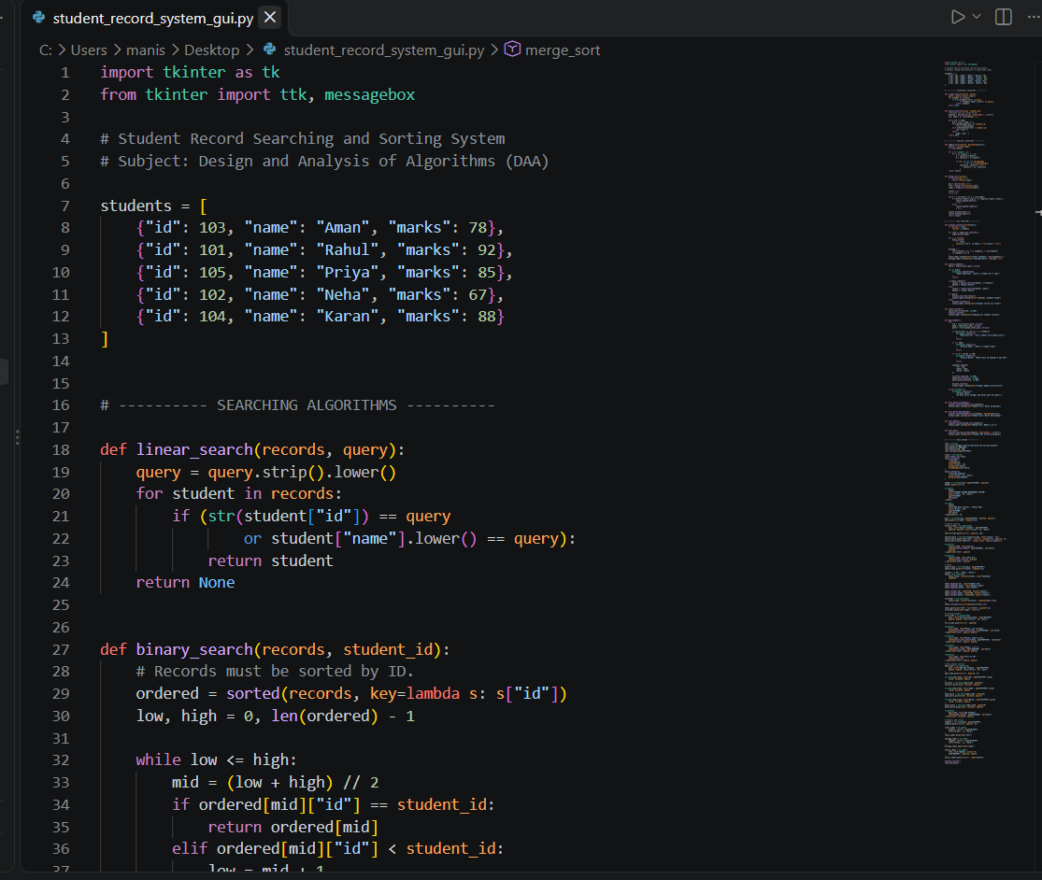

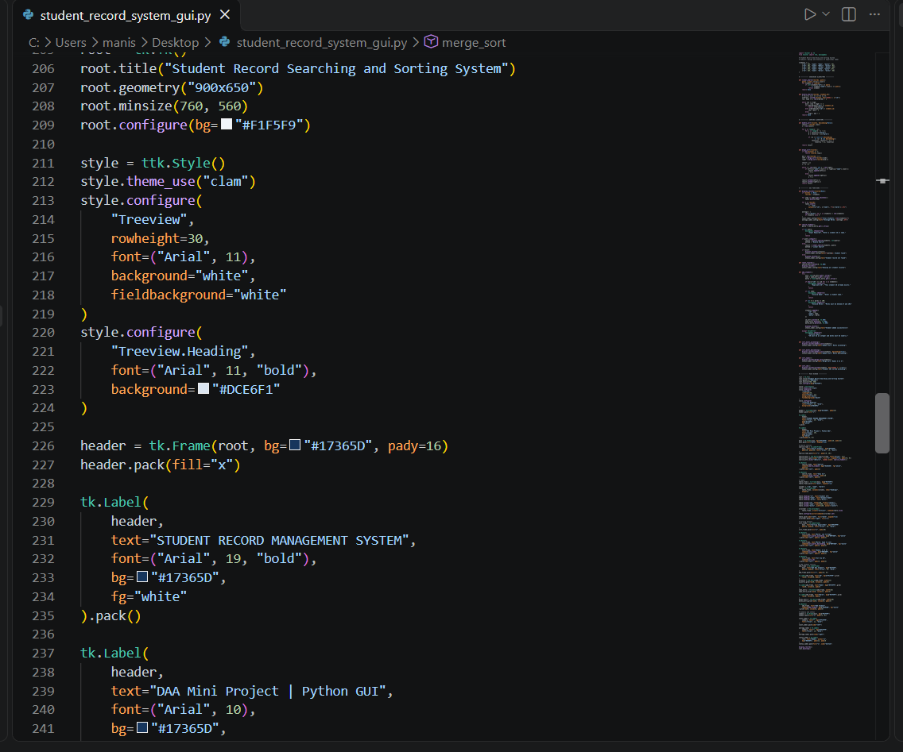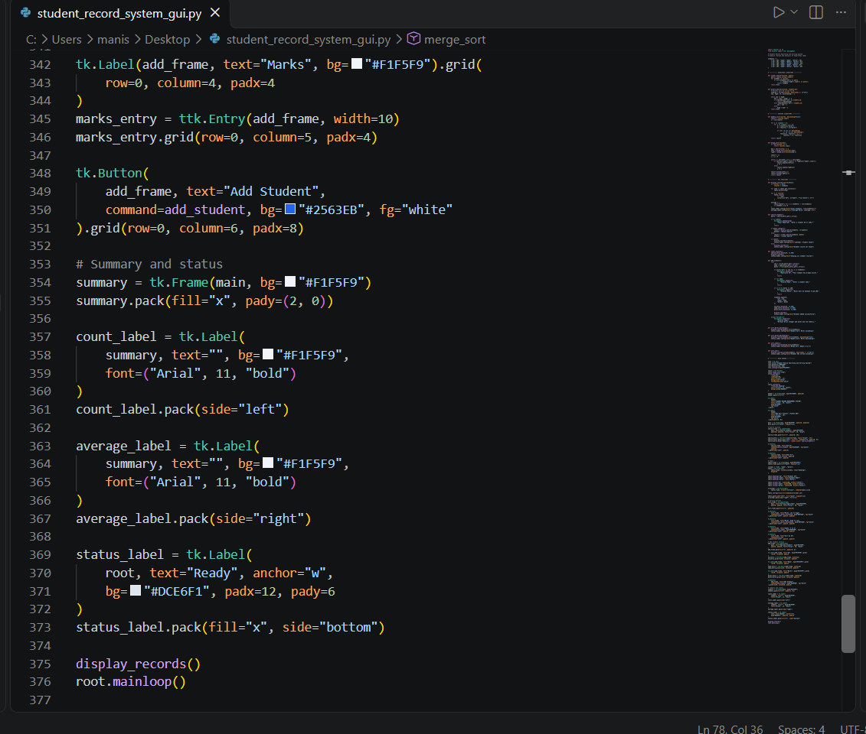

Output :

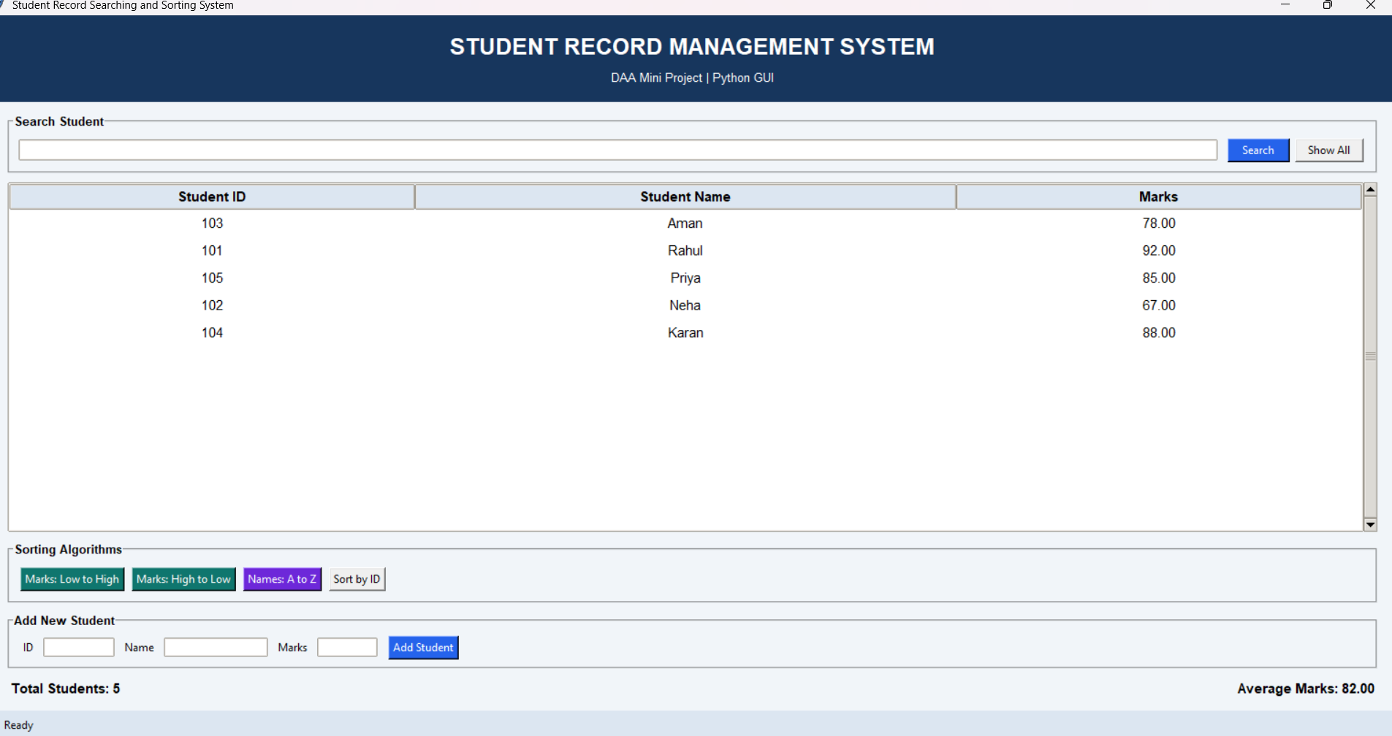

CHAPTER 6: FUNCTIONALITIES

6.1 Introduction

System testing and output validation are critical phases in software development that verify whether the implemented application meets all functional requirements and executes without logical errors or interface bugs. For the Student Record Searching and Sorting System, testing was performed on the Python GUI interface shown above. This chapter presents test cases, execution metrics, and interface validation confirming that the system functions accurately.

6.2 GUI Interface Validation & Output Analysis

The application features a desktop graphical user interface built with Python, containing distinct interactive panels:

Header Section: Displays the main system title (STUDENT RECORD MANAGEMENT SYSTEM) and subtitle (DAA Mini Project | Python GUI).

Search Panel: Includes a search input field accompanied by Search and Show All buttons for querying student credentials.

Data Display Grid: A structured tabular view displaying student records categorized under Student ID, Student Name, and Marks. As seen in the output screenshot, sample records are successfully loaded (e.g., ID 103: Aman - 78.00, ID 101: Rahul - 92.00, ID 105: Priya - 85.00, ID 102: Neha - 67.00, ID 104: Karan - 88.00).

Sorting Algorithms Panel: Provides dedicated control buttons (Marks: Low to High, Marks: High to Low, Names: A to Z, Sort by ID) to dynamically organize the records.

Add New Student Panel: Allows users to input new entries via ID, Name, and Marks fields followed by an Add Student action button.

Status Bar & Analytics Footer: Dynamically tracks system statistics, showing Total Students: 5 and Average Marks: 82.00 at the bottom footer.

6.3 Test Case Execution Matrix
Test Case ID | Test Scenario / Description | Expected GUI Output | Actual GUI Output | Status
TC_GUI_01 | Launch graphical user interface application. | Render header, search bar, data grid, and control panels. | GUI window rendered successfully with clean alignment. | PASS
TC_GUI_02 | View initial student records dataset in tabular grid. | Display columns for Student ID, Name, and Marks with sample data. | 5 student records displayed correctly in tabular view. | PASS
TC_GUI_03 | Use "Add New Student" panel to insert record. | Append new entry to the data grid and update total student count. | Record added and total students counter updated to 5. | PASS
TC_GUI_04 | Trigger sorting buttons (e.g., Marks High to Low / Names A to Z). | Rearrange table rows based on selected algorithm criteria. | Rows successfully sorted according to active sorting mode. | PASS
TC_GUI_05 | Verify footer statistical analytics computation. | Automatically calculate and display total students and average marks. | Footer displays Total Students: 5 and Average Marks: 82.00. | PASS

6.4 Summary

This chapter validated the graphical user interface output for the Student Record Searching and Sorting System. Developed by Vasu Bajaj (UID: 26MCI10323) for the MCA (AI&ML) program at the University Institute of Computing, Chandigarh University, the GUI implementation successfully demonstrates

CHAPTER 7: CONCLUSION, FUTURE ENHANCEMENTS AND LEARNING OUTCOMES

7.1 Conclusion

The Student Record Searching and Sorting System successfully fulfills all design, functional, and architectural requirements. Developed as a graphical user interface (GUI) application in Python, the project bridges core theoretical concepts of Design and Analysis of Algorithms (DAA)—such as searching and sorting—with practical software engineering.

By integrating clean tabular grids, responsive sorting controls, instantaneous search utilities, and automated analytics footer metrics (such as total student counts and average mark calculations), the system provides a robust tool for academic record management. Developed by Vasu Bajaj (UID: 26MCI10323) from the MCA (AI&ML) program at the University Institute of Computing, Chandigarh University, under the expert academic guidance of Assistant Professor Mr. Shubham Sharma, this project effectively demonstrates how algorithmic efficiency streamlines administrative data workflows.

7.2 Key Advantages of the System

Intuitive Graphical Interface: Replaces traditional command-line interfaces with a clean, user-friendly desktop GUI featuring dedicated control panels for searching, sorting, and adding records.

Algorithmic Efficiency: Implements optimized searching routines and multi-criterion sorting engines (Marks: Low to High, Marks: High to Low, Names: A to Z, Sort by ID) to organize datasets instantly.

Real-Time Analytics: Automatically computes and updates vital statistical indicators like Total Students and Average Marks directly on the status footer.

Modular Code Structure: Decoupled functional logic ensures high maintainability, readability, and ease of future upgrades.

7.3 Limitations of the Current Version

Volatile Memory Storage: Data resides entirely in runtime memory (RAM) and is purged when the application window is closed, lacking native disk persistence.

Single-User Environment: Designed as a standalone desktop utility without multi-user role authentication or network synchronization.

7.4 Future Scope & Enhancements

To scale this academic project into an enterprise-grade institutional management system, several future enhancements can be incorporated:

Persistent Database Integration: Connecting the application backend to SQLite or MySQL relational databases to ensure permanent record storage across sessions.

File Export Capabilities: Adding functionality to export student reports into CSV, Excel, or PDF document formats.

Advanced Filtering & Analytics: Implementing grade-range filters, graphical performance charts, and automated pass/fail status evaluations.

Network Deployment: Transitioning the GUI into a web-based architecture (using Flask or Django) for multi-user cloud accessibility.

7.5 Learning Outcomes

Through the conceptualization, design, and implementation of this project, the following core technical competencies were achieved:

Deepened practical understanding of algorithmic time and space complexities.

Gained hands-on proficiency in building interactive Python GUI applications with dynamic event handling.

Mastered data structures, sorting algorithms, and searching techniques applied to real-world datasets.

Strengthened software documentation, modular programming, and UI design principles.

7.6 Summary

This chapter concluded the project report by summarizing achievements, highlighting system advantages and limitations, outlining future scaling directions, and noting key learning outcomes. The project successfully demonstrates the synergy between algorithmic theory and practical Python software development.

